General Preparation Rules of Papers
for the Proceedings of the ISEEE-2009

First A. Author, Second B. Author, Jr., and Third C. Author

Abstract—These instructions give you guidelines for preparing papers for ISEEE-2009 Symposium’s Proceedings. Use this document as a template if you are using Microsoft Word 6.0 or later. Otherwise, use this document as an instruction set. Paper titles should be written in uppercase and lowercase letters, not all uppercase. Avoid writing long formulas with subscripts in the title; short formulas that identify the elements are fine (e.g., "Nd–Fe–B"). Do not write "(Invited)" in the title. Full names of authors are preferred in the author field, but are not required. Put a space between authors' initials.

Index Terms—About four key words or phrases in alphabetical order, separated by commas. For a list of suggested keywords, visit the IEEE web site at http://www.ieee.org/organizations/pubs/ani_prod/keywrd98.txt

I. INTRODUCTION

THIS document is a template for Microsoft Word versions 6.0 or later. You can use it to prepare your manuscript.
ISEEE-2009 editor will not change the final formatting of your paper.
Please use the following margins: Top = 2 cm; Down = 2 cm; Left = 2 cm; Right = 2 cm; Header = 1 cm; Footer = 1 cm; Paper size = A4, 2 columns, the width of the column = 8.25 cm. Do not exceed 2-4 pages for one paper.
First line of the paragraph is at 0.36 cm from the margin. Font size of the paragraph is 10, Time New Roman. Line spacing is multiple at 1.05.

II. Helpful Hints

A. Figures
Large figures and tables may span both columns. Place figure captions below the figures; place table titles above the tables. If your figure has two parts, include the labels “(a)” and “(b)” as part of the artwork. Please verify that the figures and tables you mention in the text actually exist. Please do not include captions as part of the figures. Do not put captions in “text boxes” linked to the figures. Do not put borders around the outside of your figures. Use the abbreviation “Fig.” even at the beginning of a sentence.
Manuscript received October 9, 2001. (Write the date on which you submitted your paper for review.) This work was supported in part by the U.S. Department of Commerce under Grant BS123456 (sponsor and financial support acknowledgment goes here). F. A. Author is with the National Institute of Standards and Technology, Boulder, CO 80305 USA (corresponding author to provide phone: 303-555-5555; fax: 303-555-5555; e-mail: author@ boulder.nist.gov).
S. B. Author, Jr., was with Rice University, Houston, TX 77005 USA. He is now with the Department of Physics, Colorado State University, Fort Collins, CO 80523 USA (e-mail: author@lamar. colostate.edu).
T. C. Author is with the Electrical Engineering Department, University of Colorado, Boulder, CO 80309 USA, on leave from the National Research Institute for Metals, Tsukuba, Japan (e-mail: author@nrim.go.jp).

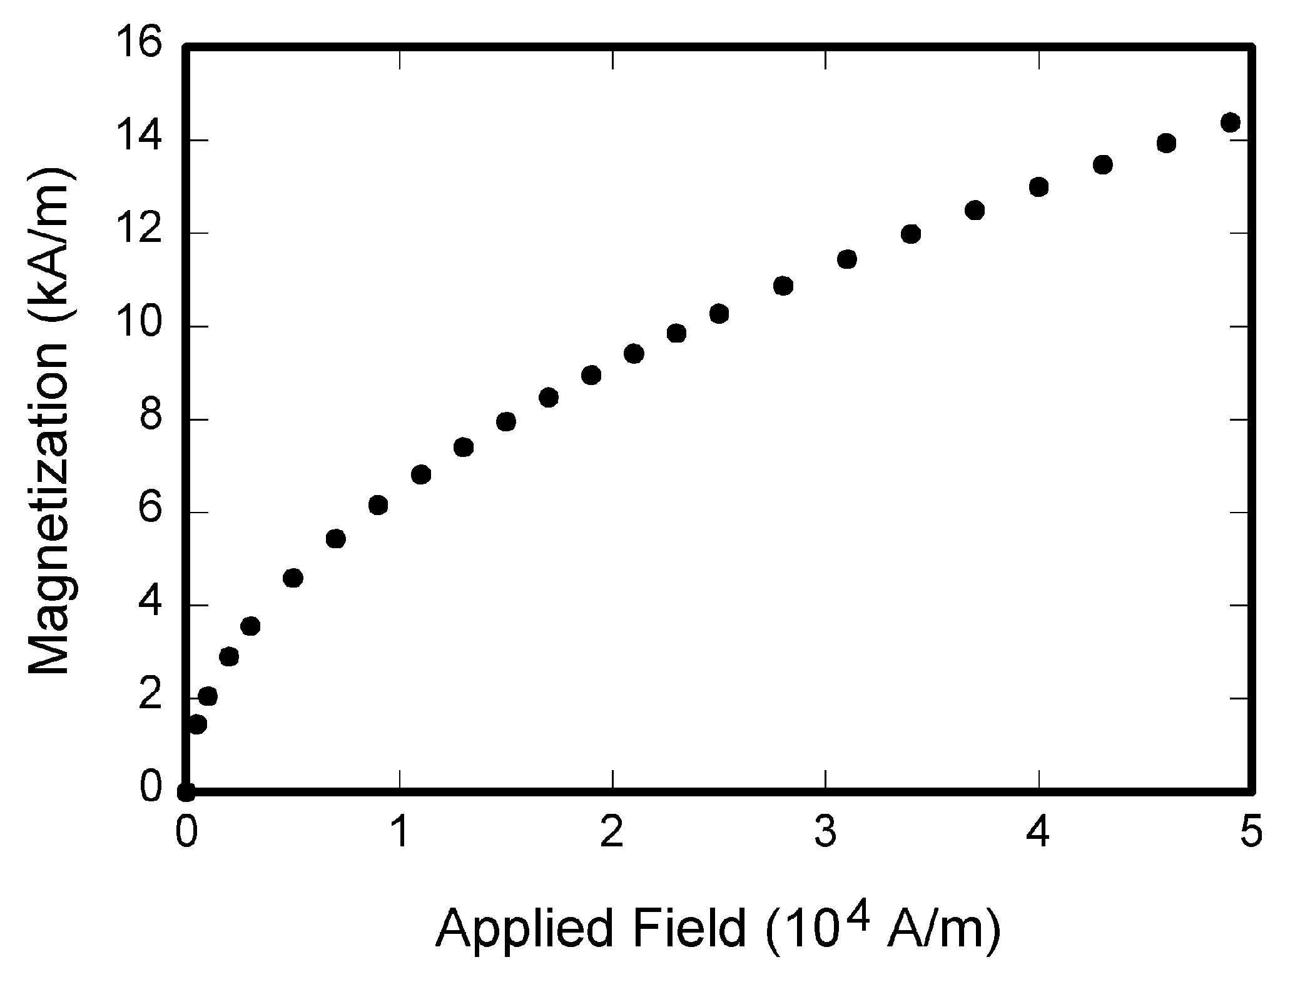
Fig. 1. Magnetization as a function of applied field. Note that “Fig.” is abbreviated. There is a period after the figure number, followed by two spaces. It is good practice to explain the significance of the figure in the caption.

Figure axis labels are often a source of confusion. Use words rather than symbols. As an example, write the quantity “Magnetization,” or “Magnetization M,” not just “M.” Put units in parentheses. Do not label axes only with units. As in Fig. 1, for example, write “Magnetization (A/m)” or “Magnetization (Am⁻¹),” not just “A/m.” Do not label axes with a ratio of quantities and units. For example, write “Temperature (K),” not “Temperature/K.” Do not use color unless it is necessary for the proper interpretation of your figures.
Do not abbreviate “Table.” Tables are numbered with Roman numerals.
No vertical lines in table. Statements that serve as captions for the entire table do not need footnote letters.

TABLE I
Units for Magnetic Properties
Symbol | Quantity | Conversion from Gaussian and  CGS EMU to SI ª
Φ | magnetic flux | 1 Mx → 10⁻⁸ Wb = 10⁻⁸ V·s
m | magnetic moment | 1 erg/G = 1 emu  → 10⁻³ A·m² = 10⁻³ J/T
M | magnetization | 1 erg/(G·cm³) = 1 emu/cm³  → 10³ A/m

B. References
Number citations consecutively in square brackets [1]. The sentence punctuation follows the brackets [2]. Multiple references [2], [3] are each numbered with separate brackets [1]–[3]. When citing a section in a book, please give the relevant page numbers [2]. In sentences, refer simply to the reference number, as in [3]. Do not use “Ref. [3]” or “reference [3]” except at the beginning of a sentence: “Reference [3] shows ... .”
The references at the end of this document are in the preferred referencing style. Give all authors’ names; do not use “et al.” unless there are six authors or more. Use a space after authors' initials. Papers that have not been published should be cited as “unpublished” [4]. Papers that have been submitted for publication should be cited as “submitted for publication” [5]. Papers that have been accepted for publication, but not yet specified for an issue should be cited as “to be published” [6]. Please give affiliations and addresses for private communications [7].
Capitalize only the first word in a paper title, except for proper nouns and element symbols. For papers published in translation journals, please give the English citation first, followed by the original foreign-language citation [8].

C. Equations
Number equations consecutively with equation numbers in parentheses flush with the right margin, as in (1). Use parentheses to avoid ambiguities in denominators.

$\int_{0}^{r2}{F(r,ϕ)\text{dr}}=[{{σr}_{2}}/ (2μ_{0})]$ (1)

Be sure that the symbols in your equation have been defined before the equation appears or immediately following. Italicize symbols (T might refer to temperature, but T is the unit tesla). Refer to “(1),” not “Eq. (1)” or “equation (1),” except at the beginning of a sentence: “Equation (1) is ... .”

D. Other Recommendations
Use one space after periods and colons. Hyphenate complex modifiers: “zero-field-cooled magnetization.”
Use a zero before decimal points: “0.25,” not “.25.” Use “cm³,” not “cc.” Indicate sample dimensions as “0.1 cm × 0.2 cm,” not “0.1 × 0.2 cm².”
If you wish, you may write in the first person singular or plural and use the active voice (“I observed that ...” or “We observed that ...” instead of “It was observed that ...”). Remember to check spelling. If your native language is not English, please get a native English-speaking colleague to proofread your paper.

IV. IEEE style guide

An excellent style manual and source of information for science writers is [9]. A general IEEE style guide, Information for Authors, is available at http://www.ieee.org/organizations/pubs/transactions/information.htm

V. Conclusion

A conclusion section is not required. Although a conclusion may review the main points of the paper, do not replicate the abstract as the conclusion. A conclusion might elaborate on the importance of the work or suggest applications and extensions.

Appendix

Appendixes, if needed, appear before the acknowledgment.

Acknowledgment

The preferred spelling of the word “acknowledgment” in American English is without an “e” after the “g.” Use the singular heading even if you have many acknowledgments

References

- G. O. Young, “Synthetic structure of industrial plastics (Book style with paper title and editor),” in Plastics, 2nd ed. vol. 3, J. Peters, Ed. New York: McGraw-Hill, 1964, pp. 15–64.
- W.-K. Chen, Linear Networks and Systems (Book style). Belmont, CA: Wadsworth, 1993, pp. 123–135.
- H. Poor, An Introduction to Signal Detection and Estimation. New York: Springer-Verlag, 1985, ch. 4.
- B. Smith, “An approach to graphs of linear forms (Unpublished work style),” unpublished.
- E. H. Miller, “A note on reflector arrays (Periodical style—Accepted for publication),” IEEE Trans. Antennas Propagat., to be published.
- J. Wang, “Fundamentals of erbium-doped fiber amplifiers arrays (Periodical style—Submitted for publication),” IEEE J. Quantum Electron., submitted for publication.
- C. J. Kaufman, Rocky Mountain Research Lab., Boulder, CO, private communication, May 1995.
- Y. Yorozu, M. Hirano, K. Oka, and Y. Tagawa, “Electron spectroscopy studies on magneto-optical media and plastic substrate interfaces(Translation Journals style),” IEEE Transl. J. Magn.Jpn., vol. 2, Aug. 1987, pp. 740–741 [Dig. 9th Annu. Conf. Magnetics Japan, 1982, p. 301].
- M. Young, The Techincal Writers Handbook. Mill Valley, CA: University Science, 1989.
- J. U. Duncombe, “Infrared navigation—Part I: An assessment of feasibility (Periodical style),” IEEE Trans. Electron Devices, vol. ED-11, pp. 34–39, Jan. 1959.
- S. Chen, B. Mulgrew, and P. M. Grant, “A clustering technique for digital communications channel equalization using radial basis function networks,” IEEE Trans. Neural Networks, vol. 4, pp. 570–578, July 1993.
- R. W. Lucky, “Automatic equalization for digital communication,” Bell Syst. Tech. J., vol. 44, no. 4, pp. 547–588, Apr. 1965.
- S. P. Bingulac, “On the compatibility of adaptive controllers (Published Conference Proceedings style),” in Proc. 4th Annu. Allerton Conf. Circuits and Systems Theory, New York, 1994, pp. 8–16.
- G. R. Faulhaber, “Design of service systems with priority reservation,” in Conf. Rec. 1995 IEEE Int. Conf. Communications, pp. 3–8.
- W. D. Doyle, “Magnetization reversal in films with biaxial anisotropy,” in 1987 Proc. INTERMAG Conf., pp. 2.2-1–2.2-6.
- G. W. Juette and L. E. Zeffanella, “Radio noise currents n short sections on bundle conductors (Presented Conference Paper style),” presented at the IEEE Summer power Meeting, Dallas, TX, June 22–27, 1990, Paper 90 SM 690-0 PWRS.
- J. G. Kreifeldt, “An analysis of surface-detected EMG as an amplitude-modulated noise,” presented at the 1989 Int. Conf. Medicine and Biological Engineering, Chicago, IL.
- J. Williams, “Narrow-band analyzer (Thesis or Dissertation style),” Ph.D. dissertation, Dept. Elect. Eng., Harvard Univ., Cambridge, MA, 1993.
- N. Kawasaki, “Parametric study of thermal and chemical nonequilibrium nozzle flow,” M.S. thesis, Dept. Electron. Eng., Osaka Univ., Osaka, Japan, 1993.
- J. P. Wilkinson, “Nonlinear resonant circuit devices (Patent style),” U.S. Patent 3 624 12, July 16, 1990.
- IEEE Criteria for Class IE Electric Systems (Standards style), IEEE Standard 308, 1969.
- Letter Symbols for Quantities, ANSI Standard Y10.5-1968.
- R. E. Haskell and C. T. Case, “Transient signal propagation in lossless isotropic plasmas (Report style),” USAF Cambridge Res. Lab., Cambridge, MA Rep. ARCRL-66-234 (II), 1994, vol. 2.
- E. E. Reber, R. L. Michell, and C. J. Carter, “Oxygen absorption in the Earth’s atmosphere,” Aerospace Corp., Los Angeles, CA, Tech. Rep. TR-0200 (420-46)-3, Nov. 1988.
- (Handbook style) Transmission Systems for Communications, 3rd ed., Western Electric Co., Winston-Salem, NC, 1985, pp. 44–60.
- Motorola Semiconductor Data Manual, Motorola Semiconductor Products Inc., Phoenix, AZ, 1989.
- (Basic Book/Monograph Online Sources) J. K. Author. (year, month, day). Title (edition) [Type of medium]. Volume(issue). Available: http://www.(URL)
- J. Jones. (1991, May 10). Networks (2nd ed.) [Online]. Available: http://www.atm.com
- (Journal Online Sources style) K. Author. (year, month). Title. Journal [Type of medium]. Volume(issue), paging if given. Available: http://www.(URL)
- R. J. Vidmar. (1992, August). On the use of atmospheric plasmas as electromagnetic reflectors. IEEE Trans. Plasma Sci. [Online]. 21(3). pp. 876—880. Available: http://www.halcyon.com/pub/journals/21ps03-vidmar

First A. Author (M’76–SM’81–F’87) and the other authors may include biographies at the end of regular papers. Biographies are often not included in conference-related papers. This author became a Member (M) of IEEE in 1976, a Senior Member (SM) in 1981, and a Fellow (F) in 1987. The first paragraph may contain a place and/or date of birth (list place, then date). Next, the author’s educational background is listed. The degrees should be listed with type of degree in what field, which institution, city, state or country, and year degree was earned. The author’s major field of study should be lower-cased.
The second paragraph uses the pronoun of the person (he or she) and not the author’s last name. It lists military and work experience, including summer and fellowship jobs. Job titles are capitalized. The current job must have a location; previous positions may be listed without one. Information concerning previous publications may be included. Try not to list more than three books or published articles. The format for listing publishers of a book within the biography is: title of book (city, state: publisher name, year) similar to a reference. Current and previous research interests ends the paragraph.
The third paragraph begins with the author’s title and last name (e.g., Dr. Smith, Prof. Jones, Mr. Kajor, Ms. Hunter). List any memberships in professional societies other than the IEEE. Finally, list any awards and work for IEEE committees and publications. If a photograph is provided, the biography will be indented around it. The photograph is placed at the top left of the biography. Personal hobbies will be deleted from the biography.

